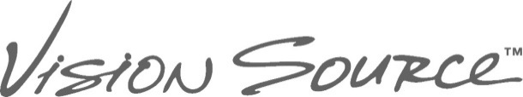@ Jordan Landing
Contact Lens Evaluation Policy
Contact lenses are medical devices regulated by the FDA and are available by prescription only. Professional care must be taken to ensure appropriate fitting parameters and eye health. Improper wear, infrequent replacement, or inadequate cleaning can lead to negative complications including vision impairment or loss. Upon completion of a comprehensive exam, a patient is eligible for a contact lens evaluation which will determine the correct material, brand, power, and fitting parameters for each patient’s contact lenses for which there is a separate fee that is often set by your insurance company, many of which provide a discount. The patient is responsible for this fee, as it requires time spent in rendering services, and some evaluations require more visits than others. A fee is always required in order to obtain a new contact lens prescription, renew an expired contact lens prescription (even when the process determines that no change is necessary in power or material to a patient’s habitual contact lens), or modify an existing contact lens prescription. The evaluation fee covers follow-up visits for sixty days, after which subsequent office visits related to contact lens wear will be $45 per visit. Evaluation fees are as follows (a detailed explanation can also be requested from the front desk):
Tier 1: $75
(most soft lenses/established wearers/minimal change)
Tier 2: $125
(new wearers/gas permeable/custom soft lenses)
Tier 3: $500
(scleral and other specialty lenses)

Usually, a 1-2 week follow-up visit is required in the evaluation process. It is important that you show for your follow up appointment wearing your contact lenses. Some evaluations also require ordering diagnostic lenses. While some contact lenses are available as disposable trials, others must be ordered from the manufacturer; which include rigid gas permeable lenses, specialty soft lenses, and hybrid lenses. Such lenses are warranted for 90 days during the fitting process. As long as the lenses are returned to the manufacturer within the allotted time period, adjustments can be made to power and material to optimize a patient’s contact lens fit. If such lenses are not returned, however, the patient’s account will be billed for the cost of the lenses. The doctors and staff of Vision Source @ Jordan Landing will do everything possible to maximize your contact lens experience. After the patient and the doctor are satisfied with the fit, vision, and comfort of the contact lenses, the patient will receive a copy of his/her contact lens prescription per the guidelines of the FTC’s “Contact Lens Rule” (2004) unless he or she requests not to receive a copy.

Patient Name (Please Print) _________________________________________________________________

Signed: ________________________________________________________ Date _____________________
If you are signing as a personal representative of the patient, please indicate your relationship
______________________________________________ _____________________
Representative Relationship to Patient

Updated May 2022

